**Project Name: Online Food Ordering System**

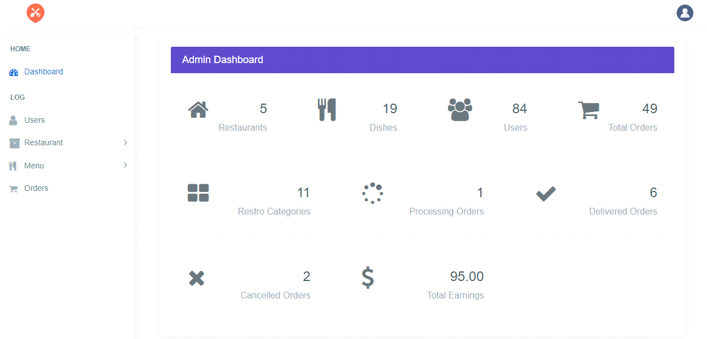

**1. Admin Homepage Dashboard**

**1.1 “Food Logo”** should be present on the Admin Homepage at the top left corner of the admin module.

**1.2 “Profile User Icon”** should be present on the Admin Homepage at the top right corner of the admin module and by clicking the Profile User Icon “Logout” text should be displayed.

**1.3 “Home”** tab should be present below the Food Logo on left side of the page.

**1.4** Below the Home Tab, “**Dashboard”** link should be present.

**1.5** Below the Dashboard Link, “**Log”** Tab should be present.

**1.6** Below the Log Tab, “**Users Link”, “Restaurant Dropdown”, “Menu Dropdown”, “Orders”** Link should be present.

**1.7** In Centre of the Admin Homepage, “**Admin Dashboard”** should be present.

**1.8** In Admin Dashboard, Logo with “**Restaurants”, “Dishes”, “Users”, “Total Orders”** should be present one next to another in single row.

**1.9** Below the Restaurants, Dishes, Users, Total Orders, Logo with “**Restro Categories”, “Processing Orders”, “Delivered Orders”** should be present one next to another in one row.

**1.10** Below the Restro Categories, Processing Orders, Delivered Orders, Logo with “**Cancelled Orders”, “Total Earnings”** should be present one next to another in single row.

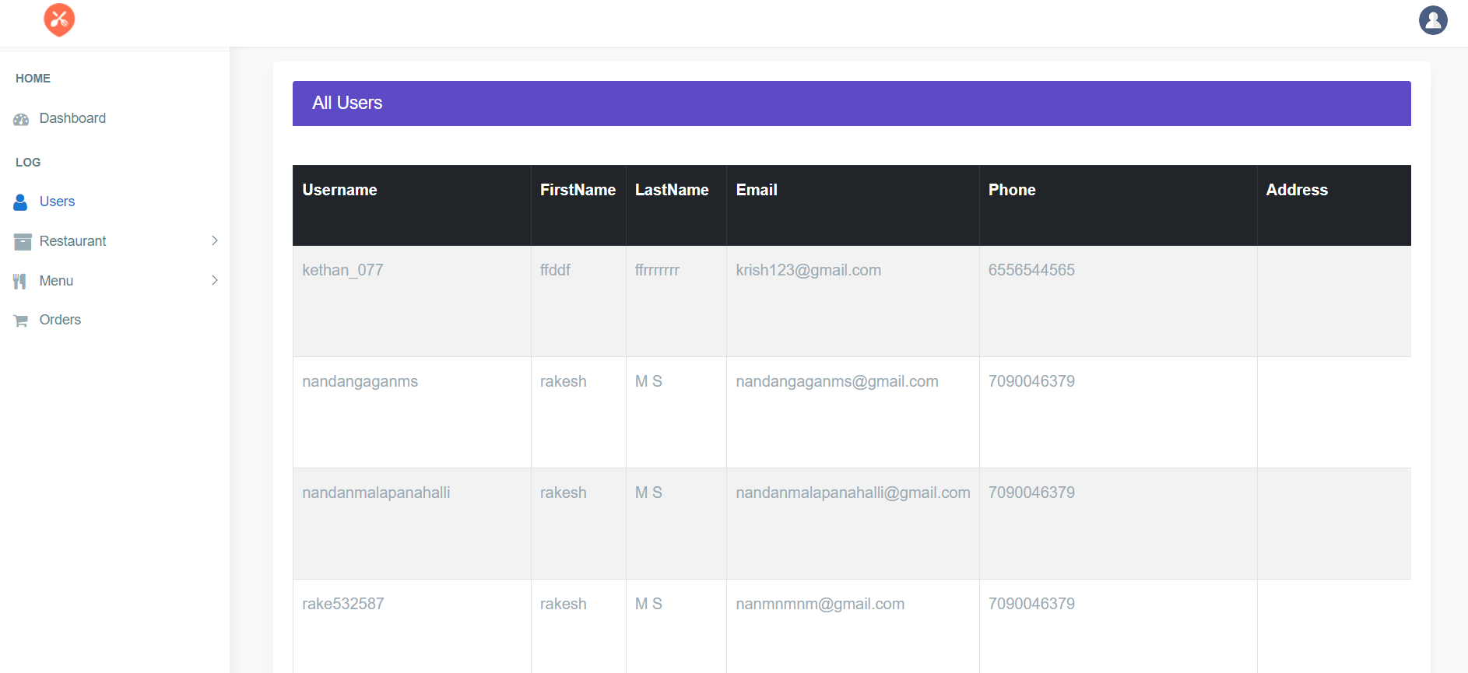

**2. All Users Page of the Admin module**

**2.1 “Food Logo”** should be present on the Admin Homepage at the top left corner of the admin module.

**2.2 “Profile User Icon”** should be present on the Admin Homepage at the top right corner of the admin module.

**2.3 “Home”** tab should be present below the Food Logo on left side of the page.

**2.4** Below the Home Tab, “**Dashboard”** link should be present.

**2.5** Below the Dashboard Link, “**Log”** Tab should be present.

**2.6** Below the Log Tab, “**Users Link”, “Restaurant Dropdown”, “Menu Dropdown”, “Orders”** Link should be present.

**2.7** In Center of the page, “**All Users”** label should be present.

**2.8** Below the All Users label, Six Columns should be present.

**2.9** The First Column should contain the label name as “**Username”**, it should contain the names of the users one below the another.

**2.10** The Second Column should contain the label name as “**FirstName”**, it should contain the Firstname of the users one below the another.

**2.11** The Third Column should contain the label name as “**LastName”**, it should contain the Lastname of the users one below the another.

**2.12** The Fourth Column should contain the label name as “**Email”**, it should contain mail address of the users one below the another.

**2.13** The Fifth Column should contain the label name as “**Phone”**, it should contain the phone numbers of users one below another.

**2.14** The Sixth Column should contain the label name as “**Address”**, it should contain the Address of the users one below another. 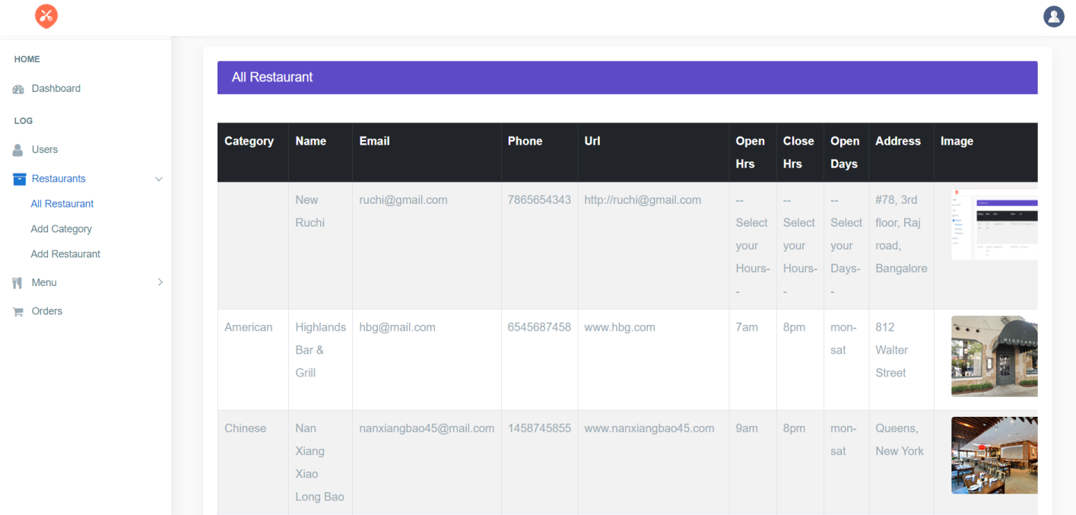

**3.All Restaurant page of the Admin Module**

**3.1 “Food Logo”** should be present on the Admin Homepage at the top left corner of the admin module.

**3.2 “Profile User Icon”** should be present on the Admin Homepage at the top right corner of the admin module.

**3.3 “Home”** tab should be present below the Food Logo on left side of the page.

**3.4** Below the Home Tab, “**Dashboard”** link should be present.

**3.5** Below the Dashboard Link, “**Log”** Tab should be present.

**3.6** Below the Log Tab, “**Users Link”, “Restaurant Dropdown”, “Menu Dropdown”, “Orders”** Link should be present.

**3.7** By clicking “**Restaurant”** Dropdown, “**All Restaurants”, “Add Category”, “Add Restaurant”** should be present.

**3.8** In center of the page, “**All** **Restaurant”** Label should be present

**3.9** Below the All Restaurant label, Ten Columns should be present.

**3.10** First Column should contain the label as “**Category”**, it should contain respective data.

**3.11** Second Column should contain the label as “**Name”**, it should contain the names of Restaurants.

**3.12** Third Column should contain the label as “**Email”**, it should contain the mail address of the respective Restaurants.

**3.13** Fourth Column should contain the label as “**Phone”**, it should contain the respective phone number of the Restaurants.

**3.14** Fifth Column should contain the label as “**Url”**, it should contain Url address of the respective Restaurants.

**3.15** Sixth Column should contain the label as “**Open Hrs”**, it should contain the opening timings of the respective Restaurants.

**3.16** Seventh Column should contain the label as “**Close Hrs”**, it should contain the closing timings of the respective Restaurants.

**3.17** Eight Column should contain the label as “**Open Days”**, it should contain the respective Days.

**3.18** Ninth Column should contain the label as “**Address”**, it should contain the address of the respective Restaurants.

**3.19** Tenth Column should contain the label as “**Image”**, it should contain the Images of the respective Restaurants.

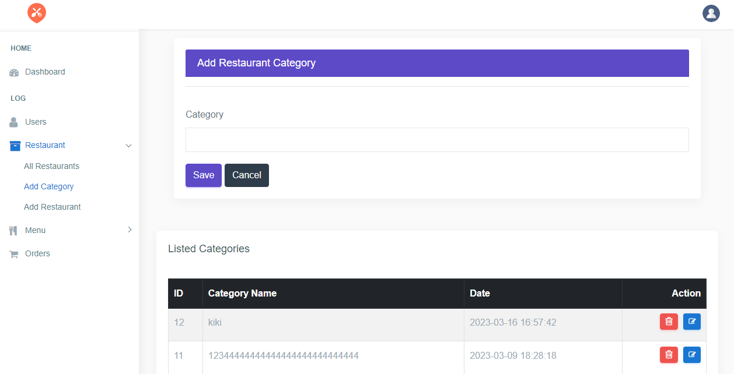

**4. Add Category Page of the Admin module**

**4.1 “Food Logo”** should be present on the Admin Homepage at the top left corner of the admin module.

**4.2 “Profile User Icon”** should be present on the Admin Homepage at the top right corner of the admin module.

**4.3 “Home”** tab should be present below the Food Logo on left side of the page.

**4.4** Below the Home Tab, “**Dashboard”** link should be present.

**4.5** Below the Dashboard Link, “**Log”** Tab should be present.

**4.6** Below the Log Tab, “**Users Link”, “Restaurant Dropdown”, “Menu Dropdown”, “Orders”** Link should be present.

**4.7** In Center of the page, “**Add Restaurant Category”** label should be present

**4.8** Below the Add Restaurant Category, “**Category”** Textfield should be present with textbox.

**4.9** Below the Category Textbox, “**Save”** Button should be present.

**4.10** Below the Category Textbox, “**Cancel”** button should be present to the right side of the Save Button.

**4.11** Below the Save and Cancel Button, “**Listed Categories”** label should be present.

**4.12** Below Listed Categories label, Four Columns should be present.

**4.13** First Column name should contain the label as “**ID”**, it should contain the numbers of the respective restaurant.

**4.14** Second Column name should contain the label as “**Category** **Name”**, it should contain name of the respective restaurant.

**4.15** Third Column name should contain the label as “**Date”**, it should contain the date.

**4.16** Fourth Column name should contain the label as Action, it should contain the “**Delete”** Radio Button along with “**Edit”** Radio Button.

**4.17** By Clicking Edit Radio Button, the Dashboard page should be displayed.

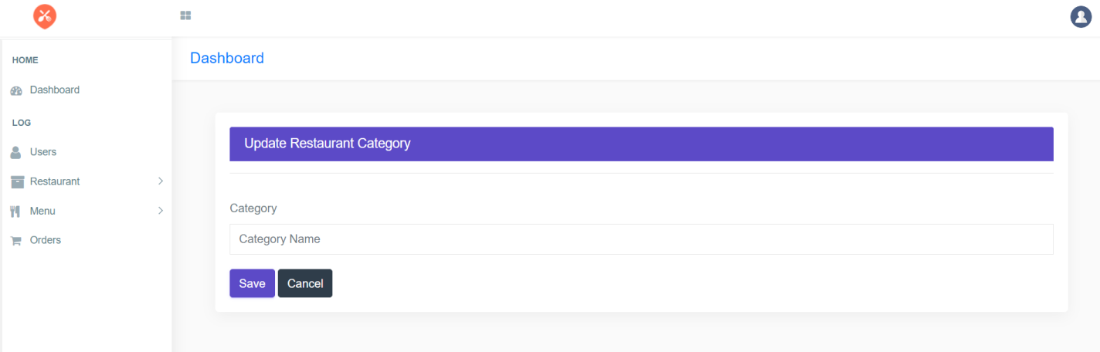

**5.Dashboard page of the Add Categories**

**5.1 “Food Logo”** should be present on the Admin Homepage at the top left corner of the admin module.

**5.2 “Profile User Icon”** should be present on the Admin Homepage at the top right corner of the admin module.

**5.3 “Home”** tab should be present below the Food Logo on left side of the page.

**5.4** Below the Home Tab, “**Dashboard”** link should be present.

**5.5** Below the Dashboard Link, “**Log”** Tab should be present.

**5.6** Below the Log Tab, “**Users Link”, “Restaurant Dropdown”, “Menu Dropdown”, “Orders”** Link should be present.

**5.7** In Center of the page, “**Dashboard”** label should be present.

**5.8** Below the Dashboard label, Update Restaurant Category should be present in the middle of the page.

**5.9** Below Update Restaurant Category, “**Category”** label should be present.

**5.10** Below Category label, a respective data of category name textfield should be present.

**5.11** Below Category textfield, “**Save”** Button should be present.

**5.12** Below Category textfield, “**Cancel”** Button should be present next to Save Button.

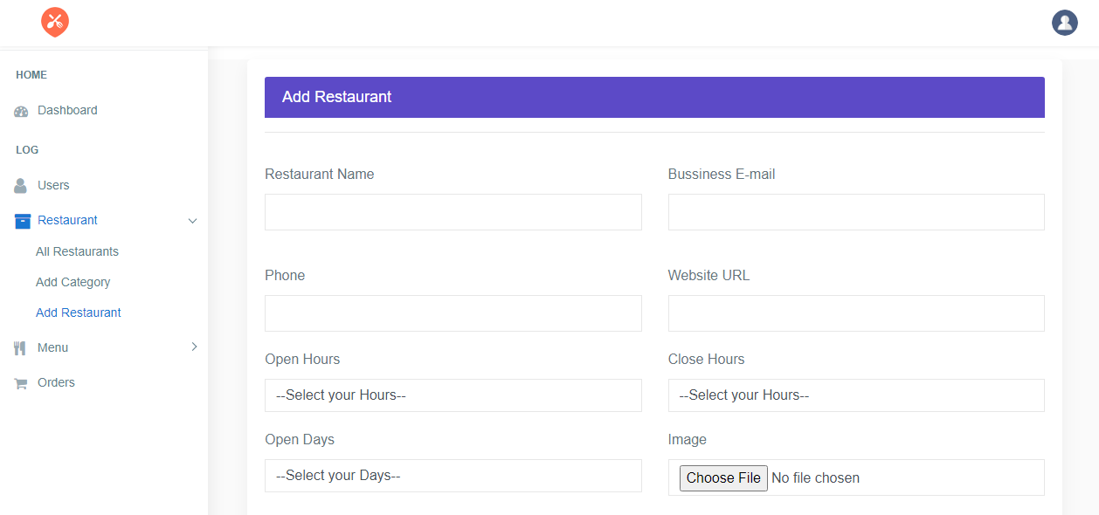

**6. Add Restaurants of the admin module**

**6.1 “Food Logo”** should be present on the Admin Homepage at the top left corner of the admin module.

**6.2 “Profile User Icon”** should be present on the Admin Homepage at the top right corner of the admin module.

**6.3 “Home”** tab should be present below the Food Logo on left side of the page.

**6.4** Below the Home Tab, “**Dashboard”** link should be present.

**6.5** Below the Dashboard Link, “**Log”** Tab should be present.

**6.6** Below the Log Tab, “**Users Link”, “Restaurant Dropdown”, “Menu Dropdown”, “Orders”** Link should be present.

**6.7** In Center of the page “**Add Restaurant”** label should be present.

**6.8** Below the Add Restaurant label, “**Restaurant name”** label should be present to the left.

**6.9** Below the Restaurant name label, Restaurant name textfield should be present.

**6.10** Below the Restaurant name label, “**Business E-mail”** label should be present next to the Restaurant name.

**6.11** Below the Business E-mail label, Business E-mail textfield should be present next to the Restaurant name textfield.

**6.12** Below the Restaurant name textfield, “**Phone”** label should be present.

**6.13** Below the Phone label, “**Phone”** label textfield should be present.

**6.14** Below the Business E-mail textfield, “**Phone”** label should be present to the left.

**6.15** Below the Phone label, “**Phone”** label textfield should be present to the left.

**6.16** Below the Business E-mail label, “**Website URL”** label should be present next to the Phone label.

**6.17** Below the Business E-mail label, Business E-mail textfield should be present.

**6.18** Below the Phone textfield, “**Open Hours”** label should be present.

**6.19** Below the Open Hours label, **“--Select your Hours--"** dropdown should be present to the left.

**6.20** Below the Website URL textfield, “**Close Hours”** label should be present next to the Open Hours label.

**6.21** Below the Close Hours label**, “--Select your Hours--"** dropdown should be present to the right.

**6.22** Below the **“--Select your Hours--"** dropdown, Open Days label should be present to the left.

**6.23** Below the Open Days label, **“--Select Your Days--"** dropdown should be present to the left.

**6.24** Below the **“--Select your Hours--"** dropdown of the Close Hours, “**Image”** label should be present to the right.

**6.25** Below the Image label, **“Choose File”** File selector along with No file choosen text should be present next to the **“--Select Your Days--"** dropdown to the right.

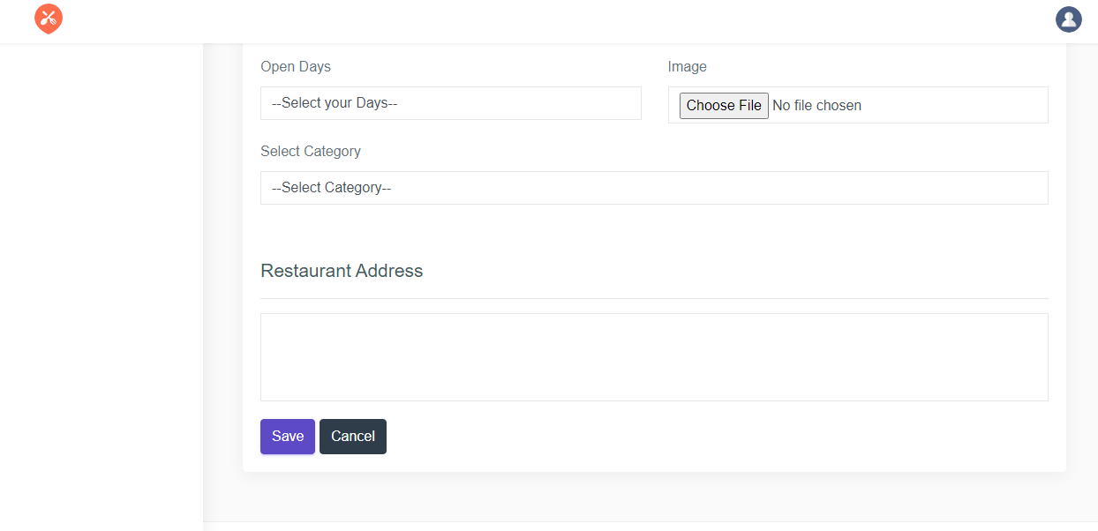

**6.26** Below the **“--Select Your Days--"** dropdown, “**Select Category”** label should be present to the left.

**6.27** Below Select Category label, **“--Select Category--"** dropdown should be present.

**6.28** Below “--Select Category--" dropdown, “**Restaurant Address”** label should be present.

**6.29** Below Restaurant Address label, Restaurant address textfield should be present.

**6.30** Below the Restaurant address textfield**, “Save”** Button should be present to the left.

**6.31** Below the Restaurant address textfield, “**Cancel”** Button should be present next to the Save Button.

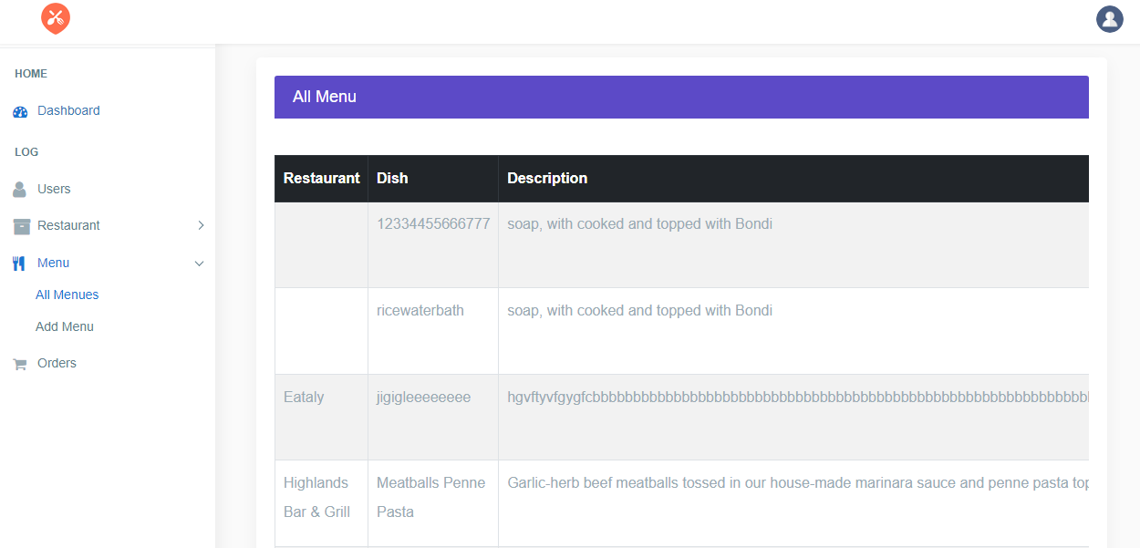

**7. All Menu page of admin module**

**7.1 “Food Logo”** should be present on the Admin Homepage at the top left corner of the admin module.

**7.2 “Profile User Icon”** should be present on the Admin Homepage at the top right corner of the admin module.

**7.3 “Home”** tab should be present below the Food Logo on left side of the page.

**7.4** Below the Home Tab, “**Dashboard”** link should be present.

**7.5** Below the Dashboard Link, “**Log”** Tab should be present.

**7.6** Below the Log Tab, “**Users Link”, “Restaurant Dropdown”, “Menu Dropdown”, “Orders”** Link should be present.

**7.7** In Center of the page “**All Menu”** label should be present.

**7.8** Below the **“All Menu”** label, Three Columns should be present.

**7.9** First Column should contain the label as **“Restaurant”.**

**7.10** Second Column should contain the label as **“Dish”.**

**7.11** Third Column should contain the label as **“Description”.**

**7.12** Below the “**All Menu”** label, Add Menu label should be present.

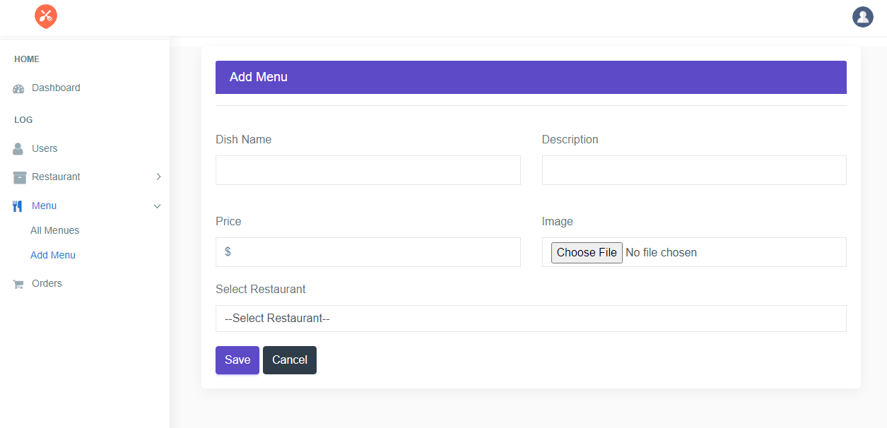

**8. Add Menu Page of the admin module**

**8.1 “Food Logo”** should be present on the Admin Homepage at the top left corner of the admin module.

**8.2 “Profile User Icon”** should be present on the Admin Homepage at the top right corner of the admin module.

**8.3 “Home”** tab should be present below the Food Logo on left side of the page.

**8.4** Below the Home Tab, “**Dashboard”** link should be present.

**8.5** Below the Dashboard Link, “**Log”** Tab should be present.

**8.6** Below the Log Tab, “**Users Link”, “Restaurant Dropdown”, “Menu Dropdown”, “Orders”** Link should be present.

**8.7** In Center of the page “**Add Menu”** label should be present.

**8.8** Below the Add Menu label, **“Dish Name”** label should be present to the left.

**8.9** Below the Dish Name label, Dish name textfield should be present.

**8.10** Below the Add Menu label, **“Description”** label should be present next to the Dish name label to the right.

**8.11** Below the Description label, Description textfield should be present next to the Dish name textfield.

**8.12** Below the Dishname textfield, **“Price”** label should be present to the left.

**8.13** Below the Price label, Price textfield should be present with the **Dollar** symbol in it.

**8.14** Below the Description textfield, **“Image”** label should be present next to the Price label.

**8.15** Below the Image label, **“Choose File”** File locator should be present along with **“No File Choosen”** text next to the Price textfield.

**8.16** Below Price textfield, “**Select Restaurant”** label should be present to the left.

**8.17** Below Select Restaurant label, **“--Select Restaurant--"** Radio button should be present to the left.

**8.18** Below **“--Select Restaurant--"** Radio button, “**Save”** Button should be present.

**8.19** Below **“--Select Restaurant--"** Radio button, “**Cancel”** Button should be present next to the Save Button.

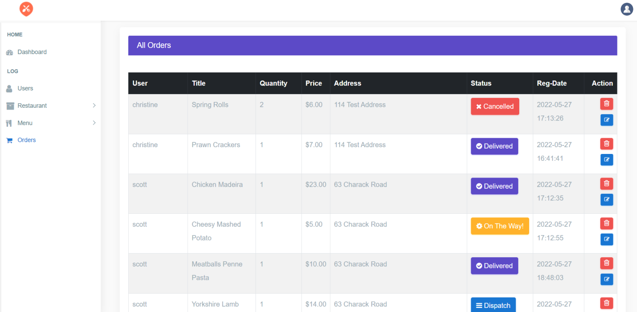

**9 All Orders Page of the Admin Module**

**9.1 “Food Logo”** should be present on the Admin Homepage at the top left corner of the admin module.

**9.2 “Profile User Icon”** should be present on the Admin Homepage at the top right corner of the admin module.

**9.3 “Home”** tab should be present below the Food Logo on left side of the page.

**9.4** Below the Home Tab, “**Dashboard”** link should be present.

**9.5** Below the Dashboard Link, “**Log”** Tab should be present.

**9.6** Below the Log Tab, “**Users Link”, “Restaurant Dropdown”, “Menu Dropdown”, “Orders”** Link should be present.

**9.7** In Center of the page “**All Orders”** label should be present.

**9.8** Below the **“All Orders”** label, Eight Columns should be present.

**9.9** The First Column should contain the label name as “**User”**, it should contain name of the user.

**9.10** The Second Column should contain the label name as “**Title”**, it should contain Title of the Food names.

**9.11** The Third Column should contain the label name as “**Quantity”**, it should contain numbers.

**9.12** The Fourth Column should contain the label name as “**Price”**, it should contain numbers.

**9.13** The Fifth column should contain the label name as “**Address”**, it should contain address of the Hotels.

**9.14** The Sixth Column should contain label name as “**Status”**, it should contain Cancelled Link, Delivered Link, On The Way Link, Dispatch Link.

**9.15** The Seventh Column should contain label name as “**Reg-Date”**, it should contain the Dates.

**9.16** The Eight Column should contain label name as “**Action”,** it should contain Delete Button.

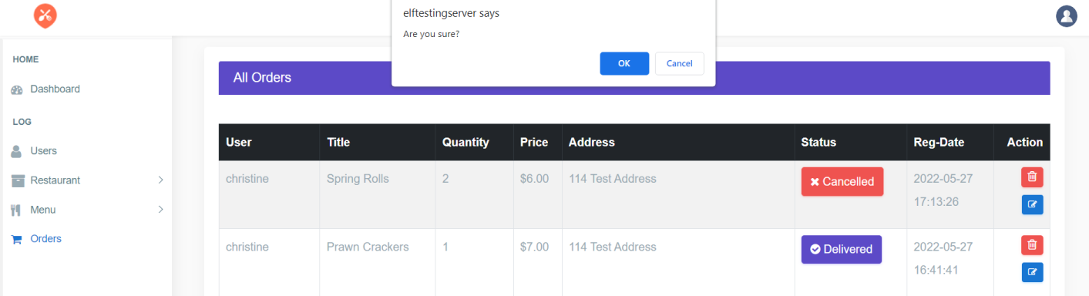

**9.17** By Clicking “**Delete”** Button, A Pop Up Message should be displayed in the current page only within the Textbox.

**9.18** A Pop Up Message should contain the text **“elftestingserver says”** inside the textbox.

**9.19** Below the text **“elftestingserver says”**, The text **“Are you sure?”** should be displayed and it should contain **“OK”** Button in the left of Pop Up message textbox and **“Cancel”** Button next to the “Ok” Button.

**9.20** In the Eight column itself, it should contain “**Edit”** Button below the Delete Button.

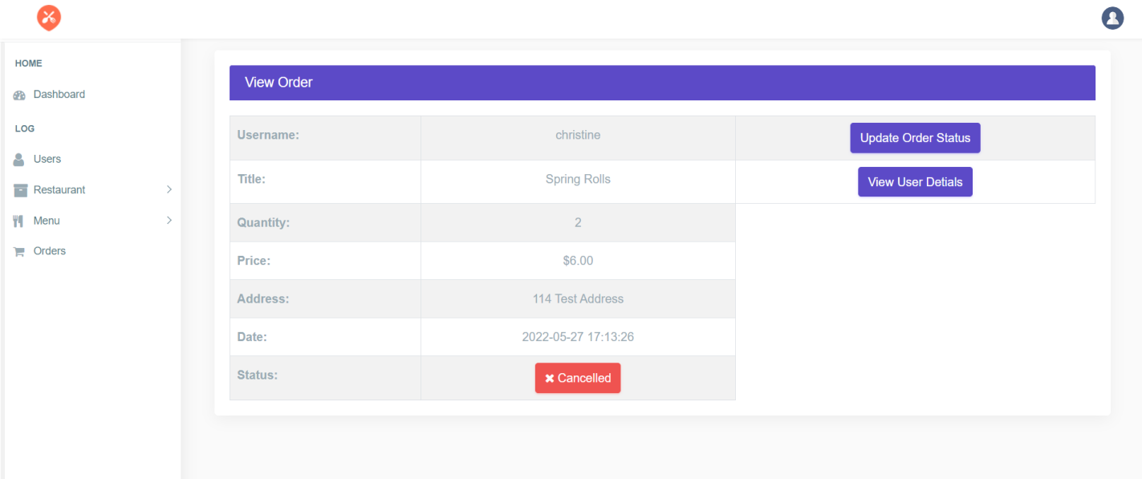

**10 View Order Page of Admin Module**

**10.1** By clicking Edit Button in All Orders Page, a new page with the label name as View Order should be created.

**10.2 “Food Logo”** should be present on the Admin Homepage at the top left corner of the admin module.

**10.3 “Profile User Icon”** should be present on the Admin Homepage at the top right corner of the admin module.

**10.4 “Home”** tab should be present below the Food Logo on left side of the page.

**10.5** Below the Home Tab, “**Dashboard”** link should be present.

**10.6** Below the Dashboard Link, “**Log”** Tab should be present.

**10.7** Below the Log Tab, “**Users Link”, “Restaurant Dropdown”, “Menu Dropdown”, “Orders”** Link should be present.

**10.8** In Center of the page “**View Order”** label should be present.

**10.9** Below the View Order label, “**Username”** label should be present along with its respective data in textbox to the left of the page.

**10.10** Below the Username label, “**Title”** label should be present along with its respective data in the textbox to the left of the page.

**10.11** Below the Title label, “**Quantity”** label should be present along with its respective data in the textbox to the left of the page.

**10.12** Below the Quantity label, “**Price”** label should be present along with its respective data in the textbox to the left of the page.

**10.13** Below the Price label, **“Address”** label should be present along with its respective data in the textbox to the left of the page.

**10.14** Below the Address label, **“Date”** label should be present along with its respective data in the textbox to the left of the page.

**10.15** Below the Date label, “**Status”** label should be present along with its respective status data in the textbox to the left of the page.

**10.16** Below the View Order label, “**Update Order Status**” Button should be present that should be located next to the respective data of username textbox to the right side of the page.

**10.17** Below the Update Order Status Button, “**View User Details”** Button should be present that should be located next to the respective data of Title textbox to the right side of the page.